NAME: __________________________________
Chapter 12.2.2 – The Cold War in Asia
Directions: Read “The Chinese Revolution” and “New Policies in Japan” on pp326-7. Address the following:
1. Why did Mao Zedong and Chang Kai-Shek put their Civil War on hold during WWII? ____________________________________________________________________________________
2. Which side did the United States choose during the Chinese Civil War? Why?
____________________________________________________________________________________
____________________________________________________________________________________

3. What events occurred in 1949 that convinced Americans they were losing the Cold War?
____________________________________________________________________________________
____________________________________________________________________________________
____________________________________________________________________________________
4. What role did Douglas MacArthur play in Japan after World War II?
____________________________________________________________________________________
____________________________________________________________________________________

5. What role did Japan play in the developing US Cold War strategy.
____________________________________________________________________________________
____________________________________________________________________________________
Lecture: The Korean War
Stage I: ___________________
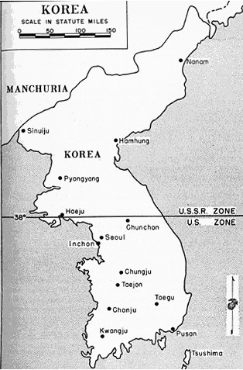

Stage II: ___________________

Stage III: __________________

Stage IV: __________________

Stage V: ___________________

Stage VI: __________________
Closure: Aftermath of Korean War
Directions: Read “Armistice Ends Fighting” and “Changes in Policy” on pp328-9. Address the following:
1. What political changes back home in America helped bring about an end to the fighting in Korea? ____________________________________________________________________________________
____________________________________________________________________________________
2. How did Eisenhower convince the Chinese to come to the negotiating table?
____________________________________________________________________________________
____________________________________________________________________________________

3. In your own words, describe the resolution of the Korean War.
____________________________________________________________________________________
____________________________________________________________________________________
____________________________________________________________________________________
4. How did the US experience in Korea cause changes to the implementation of Containment?
____________________________________________________________________________________
____________________________________________________________________________________

5. How did the US experience in Korea cause changes in the strategy of Containment?
____________________________________________________________________________________
____________________________________________________________________________________

